Top of Form

Bottom of Form

Diageo Way of Selling University (DWS)

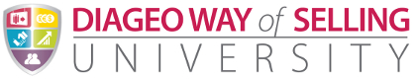

Background

The Diageo Sales/Commercial Function wanted to build on the back of the success of the iDevelop solution – see Appendix A. delivered by WBT Systems in January 2012 for the Finance / Procurement / GDBS / Manufacturing and Supply Functions. They first approached WBT in March 2012 with a view to convert a suite of excel-based business processes and tools to integrated online components hosted within the Diageo Academy, i.e. the TopClass LMS. These tools are all in the area of organisational and individual competency management and assessment.

This suite of tools/processes comes under the umbrella term DWS (Diageo Way of Selling). The three areas are as follows:

1. Standards of Excellence (SOE)
2. Platform for Growth (PFG)
3. iCAT

These areas were to be integrated into the existing Diageo Academy as part of the overall Diageo Way of Selling University.

**Diageo Definition of the DWS process:**

The Diageo Way of Selling builds our commercial capability with world-class tools and processes to deliver Diageo’s commercial vision in a consistent manner. Delivering value to our people, our customers and Diageo

The Diageo Way of Selling University is a ‘one stop shop’ which holds our diagnostics, capability & learning programmes, accreditation and best practice.

...simply, it’s the place for Customer Marketing and Sales people to go to understand current capabilities, look at development areas for current and future roles and close any gaps.

Within commercial we have two diagnostic tools; Standards of Excellence which measures and assesses your organisation and iCAT which helps individuals to understand the capabilities they need to be successful in their roles.

**Diageo Definition of Standards of Excellence process:**

Standards of Excellence is a methodology and framework that helps leaders understand their organisational capability strength and development areas. Standards of Excellence is a “total sales organisation” assessment, covering Field Sales Management, Account / Distributor Management, Customer Marketing and Reserve. Standards of Excellence diagnostic is not the way we assess individual competency, it’s about the role, tools and business processes and not the individual.

Standards of Excellence defines a clear set of organisational capabilities for markets/countries to achieve, as well as the level of proficiency required against each standard. Conducting a Standards of Excellence assessment will help build your organisational capability to deliver your strategy. An assessment will help you identify your strengths and develop an action plan to bridge capability gaps.

**Diageo Definition of iCAT process:**

iCat is the individual capability assessment framework which will move from the current Excel based tool onto the iDevelop platform on January 2013. iCAT is a capability assessment and development planning tool which helps employees think through their strengths and areas for improvement in both functional capabilities and leadership behaviours.

iCAT makes capability assessment and development planning more efficient and transparent. It provides a report based on self and line manager assessment and includes a catalogue of learning solutions to help close any skill gaps or leverage their strengths that you may have. It is easy to use and it will enable better informed development conversations between line managers and employees as part of the continuous P4G process. It can also help individuals to identify best-fit career moves and how to get there.

The iCAT framework defines a clear set of functional capabilities for all of the roles within sales and commercial. iCAT makes capability assessment and development planning more efficient as it helps you to assess your capabilities, identifying your strengths and development areas and plan your development. iCAT is also a useful career planning tool. You can use your calibrated results in iCAT and map these to any role within commercial, not just your current role. It produces a report identifying gaps for that role and enables you to have a more targeted conversation with your line manager.

Solution

The Diageo Sales/Commercial function required that their current excel based version of these processes needed to be integrated into the Diageo Academy in order to provide:

* An online user/administrative experience.
* Centralised location of data.
* Consistent UI/UX for all users.
* Ability to generate user, manager, country and market level reports of data.
* Allow for integration with the Diageo Academy LMS, particularly in the area of creating individual Development Plans for the iCAT process.
* Allow for Batch Upload of data to create the Competency Frameworks required.
* Allow for localisation into 10+ new languages (incl. Asian) of the administrative and end-user screens (incl. PDF report generation).
* Create custom End-user/Manager workflows for the iCAT Assessment process.

TopClass was able to meet these requirements by:

* Creating a completely custom Data model to meet the MS Excel based processes for the new DWS processes, as well as adding in new object/process representations that arose out of the move to an existing integrated system.
* Ensuring that the core iCAT Data Model used is compatible with the current iDevelop Data Model used to allow for the reuse of existing functionality and ease of upgrade.
* Creating custom role-based workflows to manage the various DWS Competency Assessment processes. This required relatively complex workflow routing, notification and role-based access.
* Utilising the existing TopClass SAP integration to allow for user nomination of their relevant Assessment Line Manager.
* Using existing UI/UX elements from the iDevelop and other Diageo Academy components.
* Improving on UI/UX for user critical processes, i.e. the iCAT Assessment process for end-users and managers. This was managed in conjunction with a 3rd party Multimedia Design agency.
* Providing Java Based batch data load tools to enable bulk upload of the relevant competency Framework data on demand.
* Providing a localised UI to handle all current and future languages identified.
* Utilising PDF Library APIs to allow for generation of end-user reports.
* Minimising changes required to core product functionality to ensure that regression testing and upgrades would not be adversely impacted.
* Utilising YUI JavaScript Library Charting functionality to dynamically generate relevant real-time charts for End-Users, Assessors and relevant Management.
* Using jQuery JavaScript Plugins and libraries to re-engineer UI/UX screens for end-users, while ensuring that performance for remote/low bandwidth users remained acceptable.
* Integrating with core TopClass product features, e.g. Diageo Academy Catalogue/Enrolments etc. particularly regarding the creation of Competency-based Development Plans.
* Another important element of this e-Learning solution will be the creation of e-learning content specifically for the DWS components that users will undertake to help fulfil their iCAT Development Plans.

This e-learning content will be imported as a number of future e-learning SCORM courses. These courses are scheduled to be brought on-board starting from mid February 2013.

**Selection of iCAT End-user Screens**

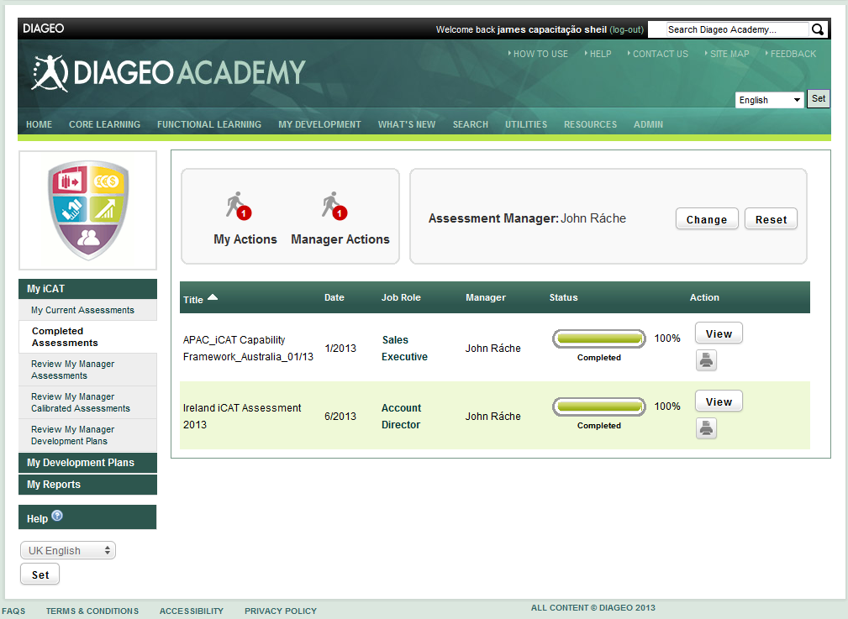

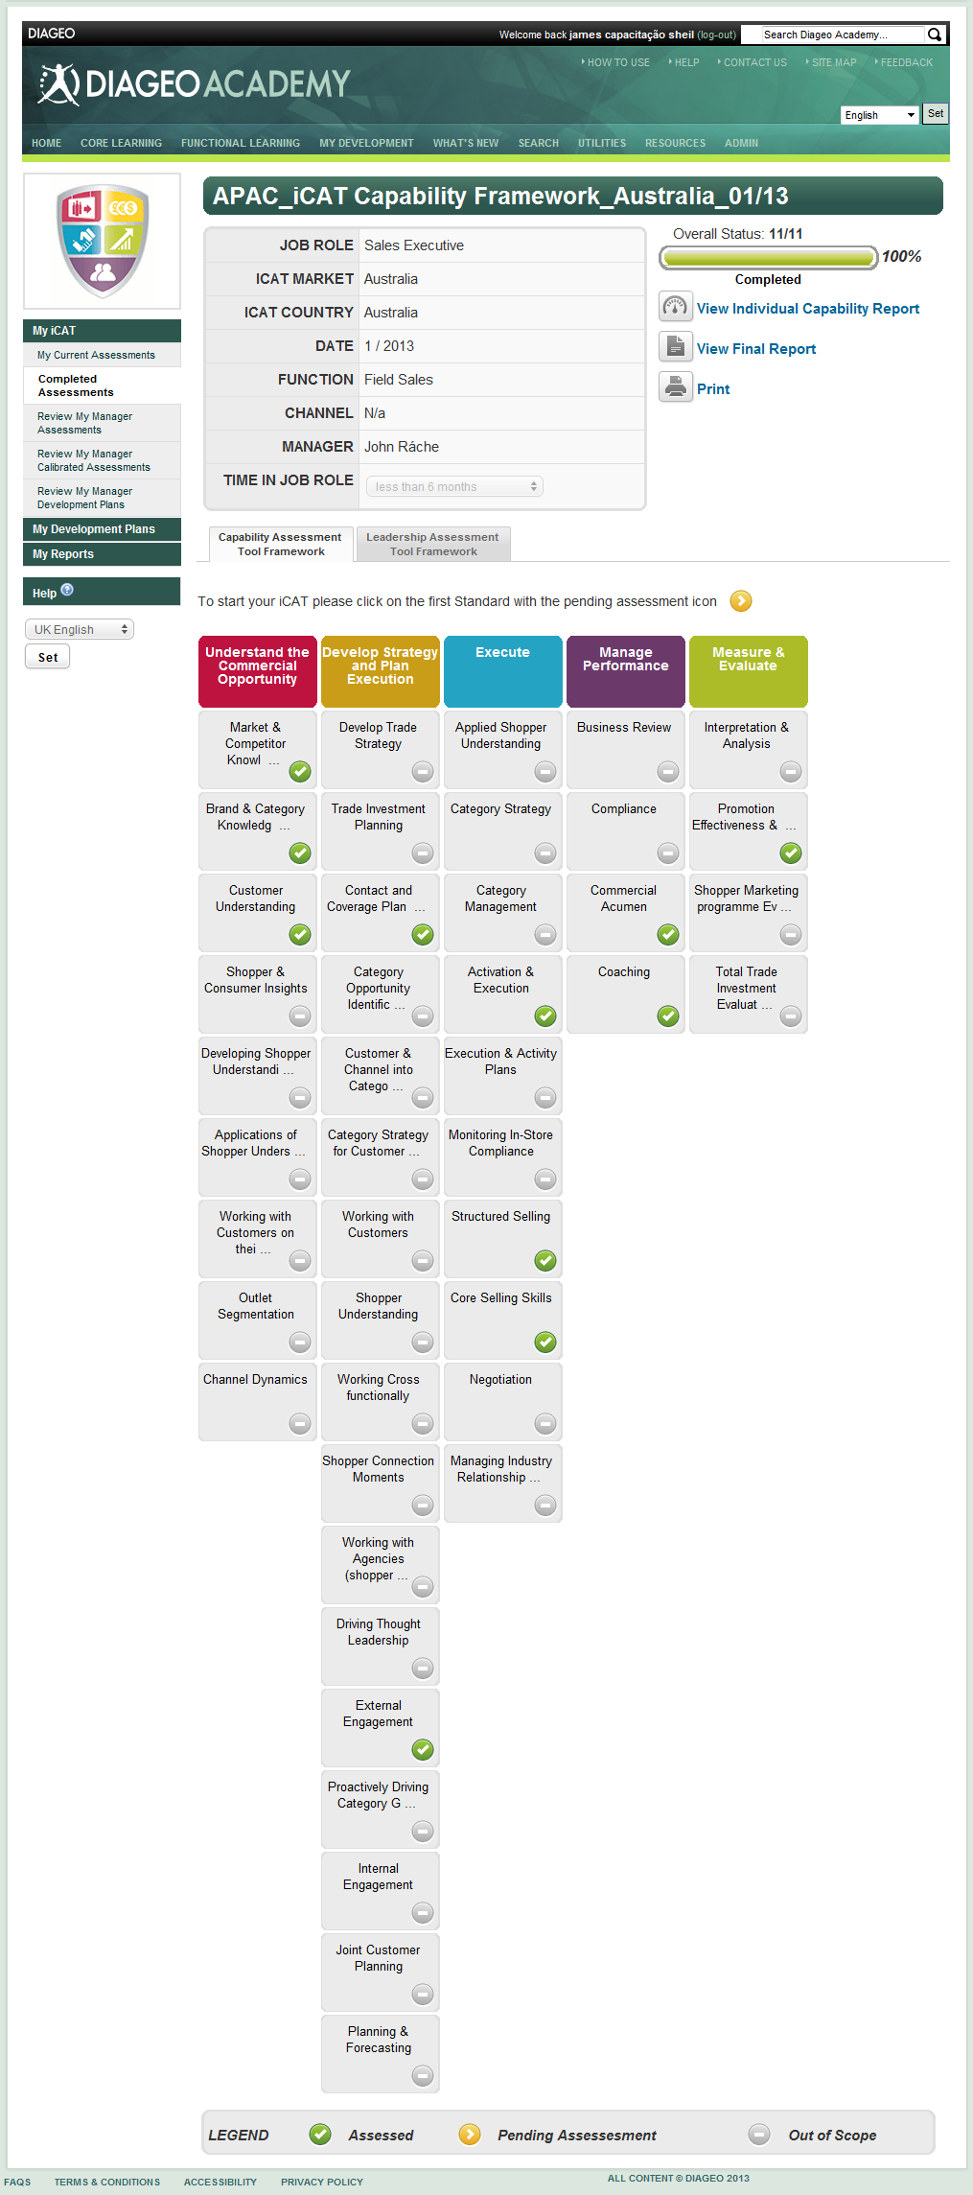

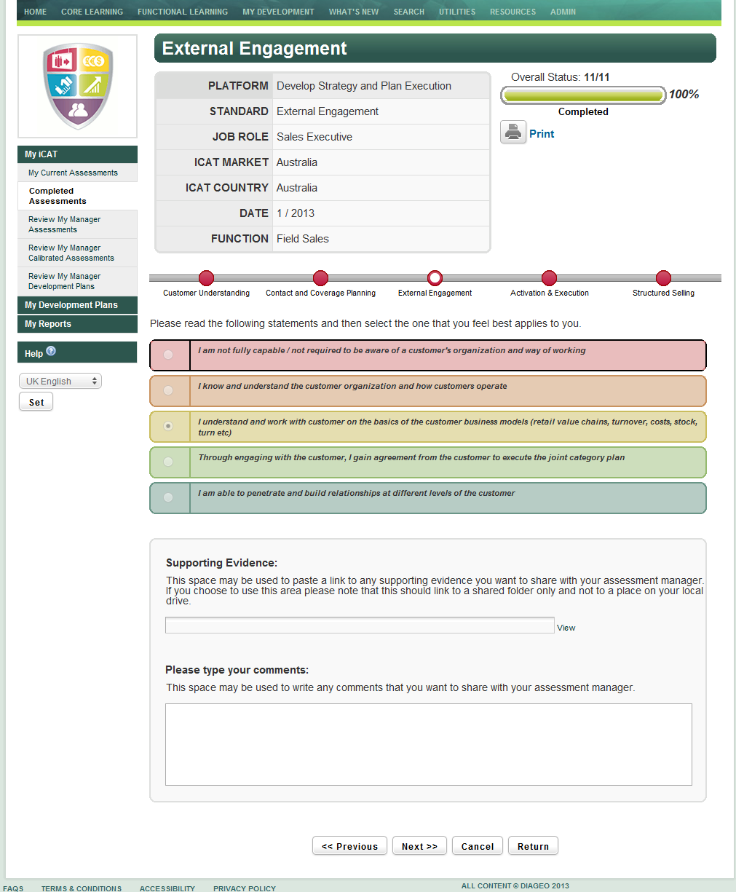

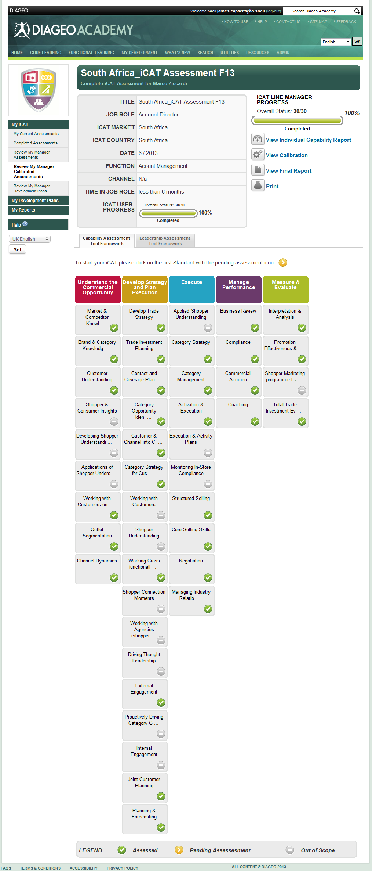

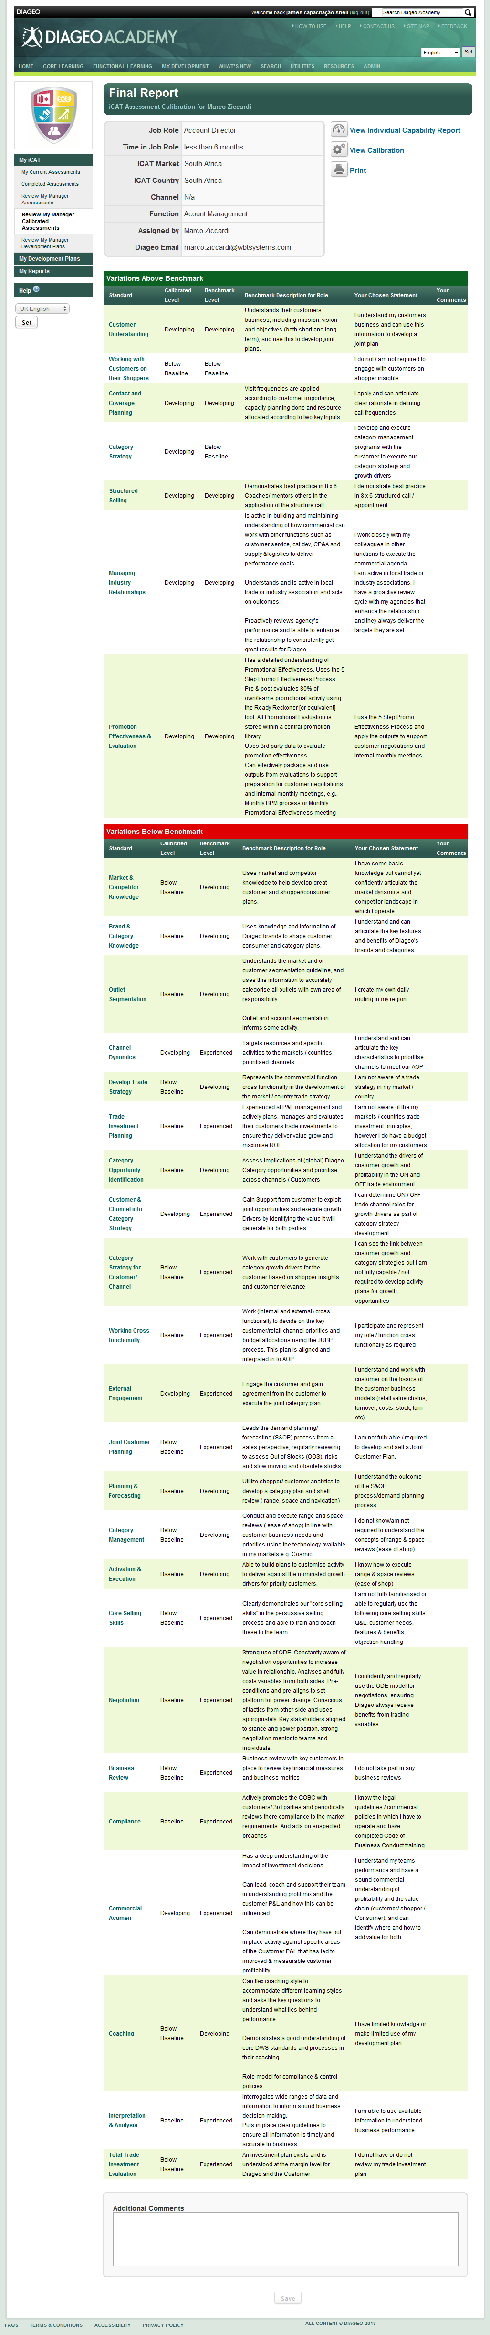

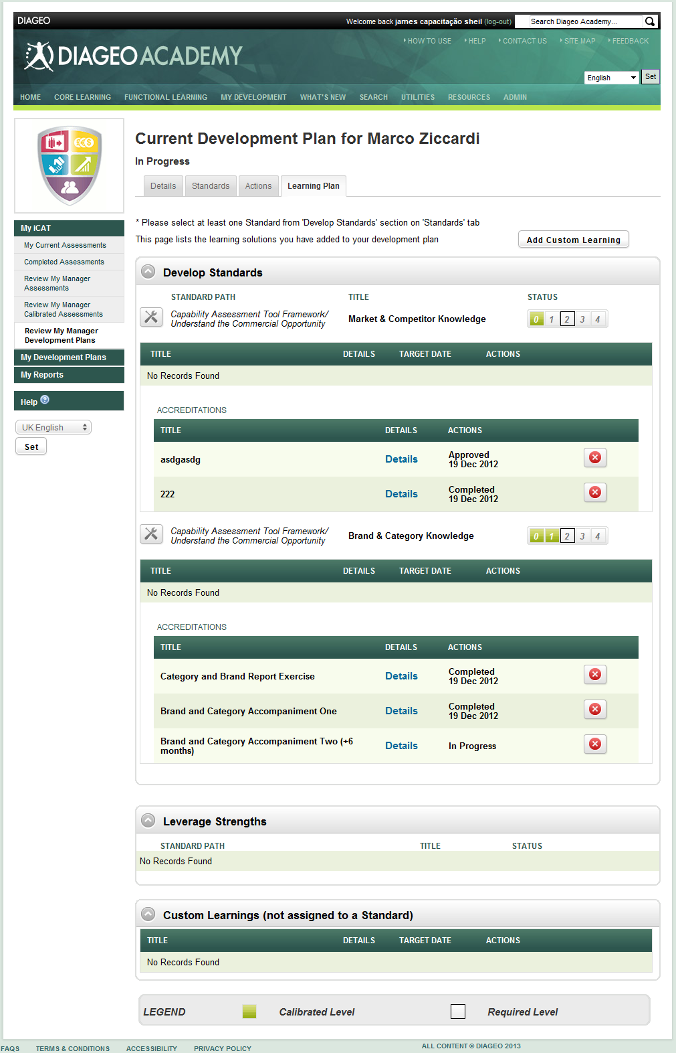

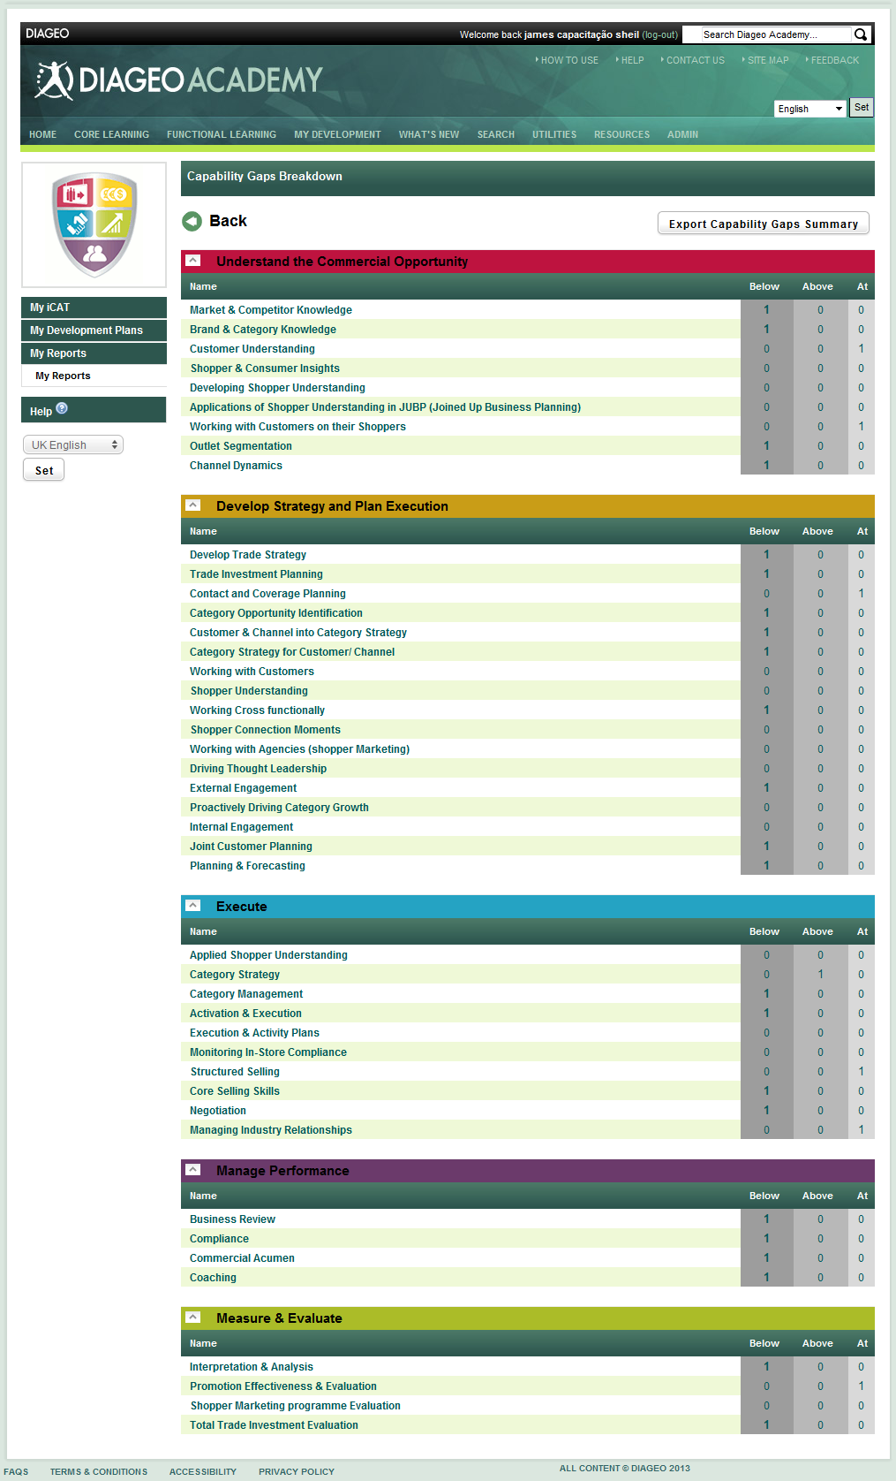

**Selection of SOE End-user Screens**

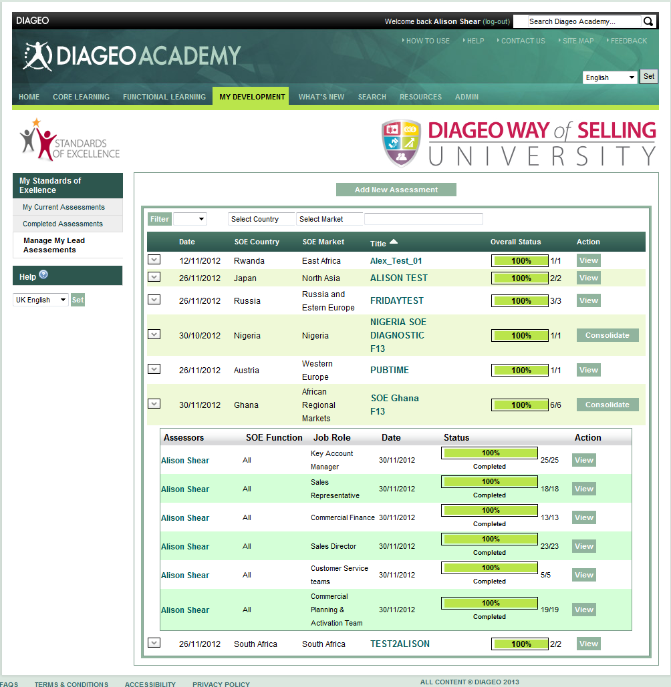

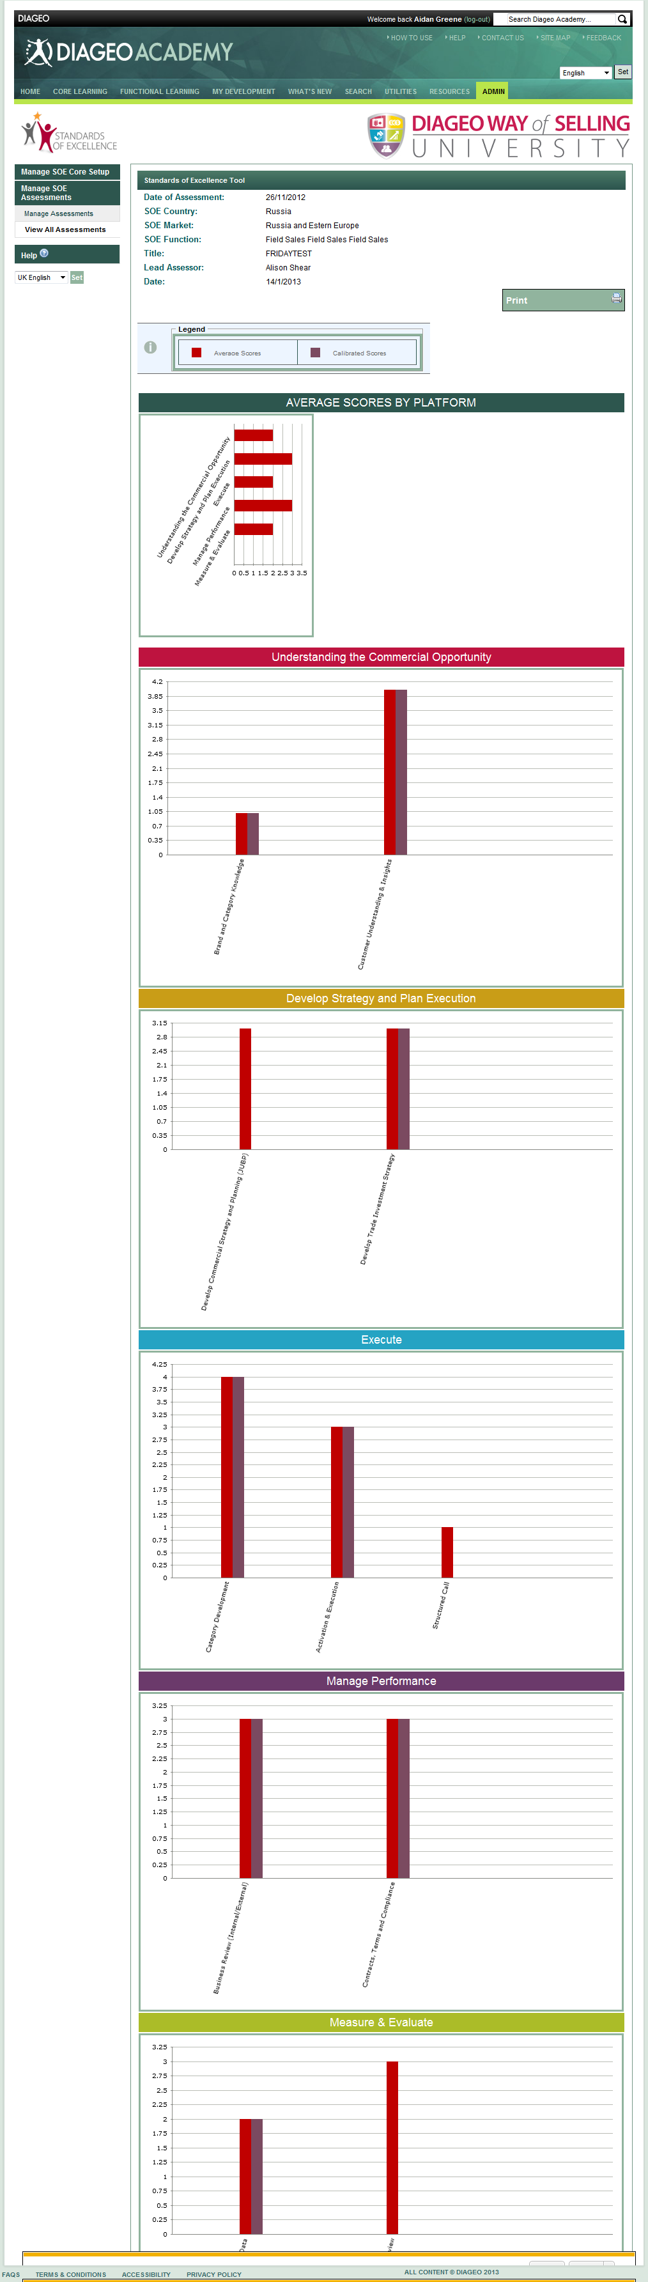

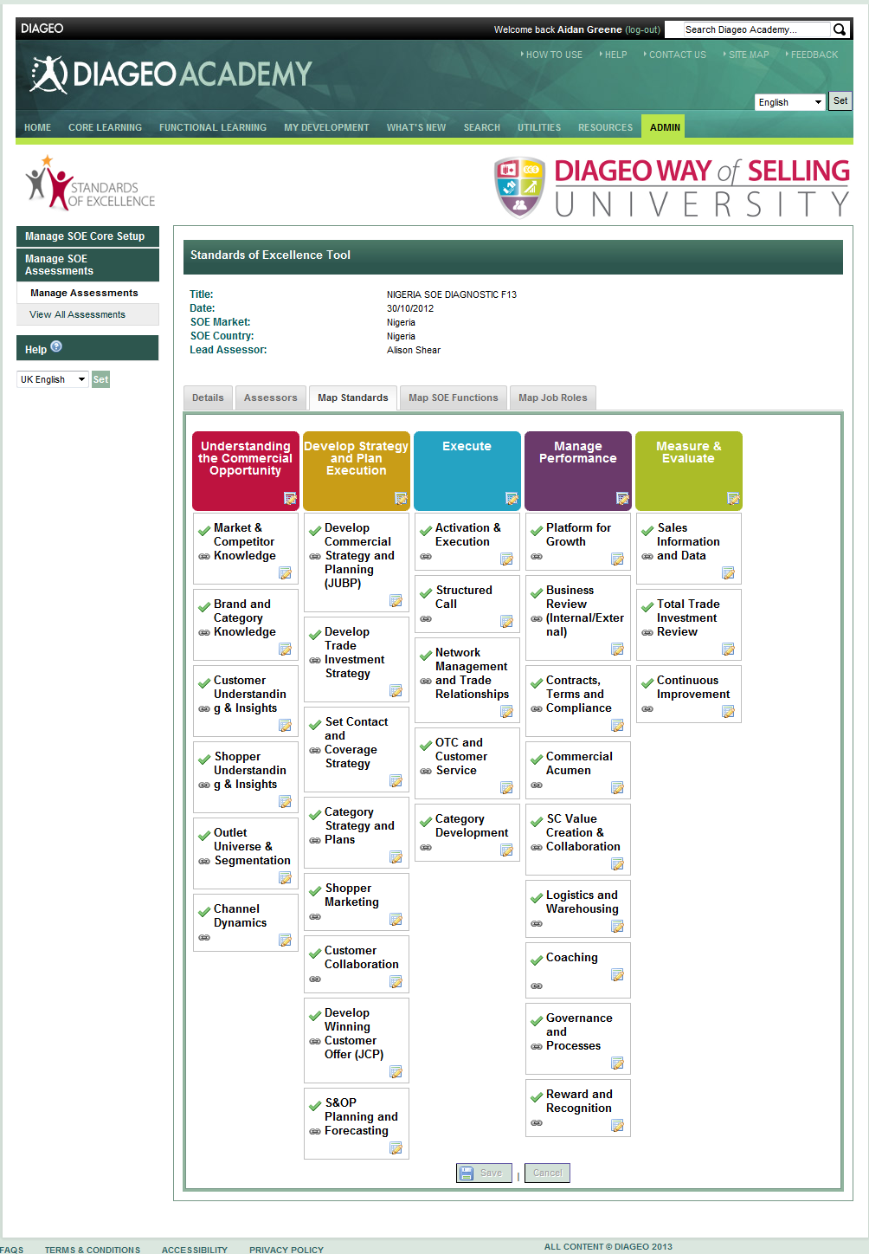

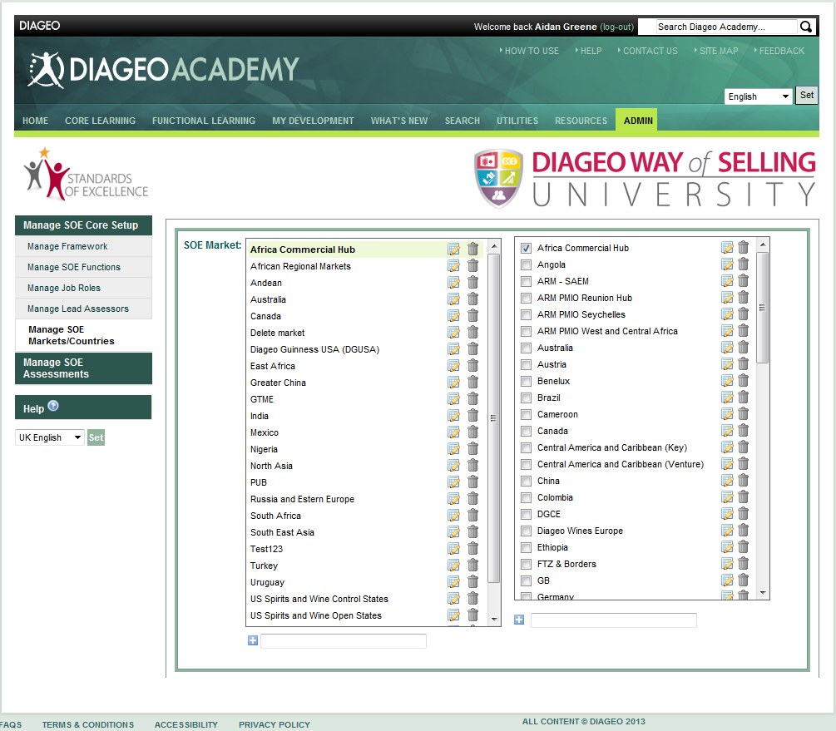

Results

The DWS suite of components was delivered on-time within a very tight schedule, i.e. from start of June 2012 – start of Jan 2013 for delivery of all components.

**Lessons Learned;**

The Future

* To be made available to various new markets with the additional upload of new language variants. Already scheduled for release in January:
  + Greek
  + Dutch
  + Italian
* Multiple DWS E-Learning Content projects scheduled from early Spring 2013.
* Region-specific Batch Data Uploader of Assessment Frameworks – new Java Integration component.
* New Reports
* Possible merge of original iDevelop Assessment component (January 2012) with new iCAT Assessment piece (January 2013).
* Upgrade to TopClass 9.

Appendix A – iDevelop

**What is iDevelop?**

iDevelop is the capability assessment and development planning tool available to everyone in Diageo. It was designed by 5 functions to help employees think through their strengths and areas for improvement in both professional capabilities and leadership behaviours. The tool provides a report based on self and line manager assessment and includes a catalogue of learning suggestions to help close the individuals' gaps or leverage their strengths. It will enable better informed development conversations between line managers and employees as part of the continuous P4G process and can also help individuals to identify best-fit career moves and how to get there.

**How will completing iDevelop benefit me?**

The functional capability frameworks define clear sets of capabilities and behaviours for Diageo professionals to have and the level of proficiency needed for key functional generic roles. iDevelop makes capability assessment and development planning more efficient and transparent.

It is the starting point of your learning journey in Diageo as it helps you to assess your capabilities, identifying your strengths and development areas and plan your development.

iDevelop is also a useful career planning tool. You can use your validated results in iDevelop and map these to any functional generic roles, not just your current role. It produces a report identifying gaps for that role and enables you to have a more targeted conversation with your line manager.

